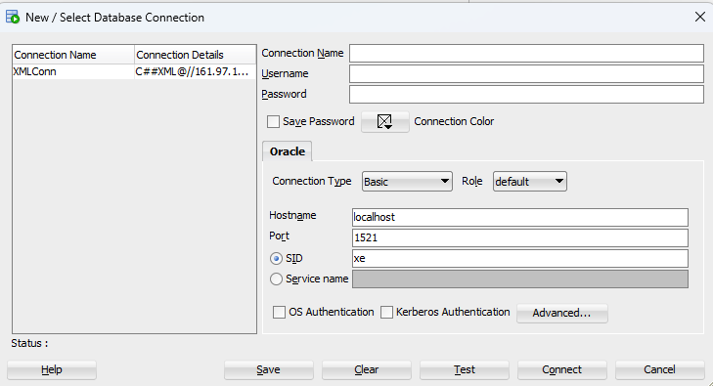

Connection Name: Give Something of your choice
User Name: C##FILE
Password: ozone
Hostname: 161.97.117.207

Click on Test. If successful the status will show as success.

